🧠 PAX A920 RS232 Custom Cable Documentation (GHL UOB Integration)
✅ Confirmed Working Wiring
DB-9 Female (to USB RS232 Adapter) → RJ45 (to PAX Docking Station L920-BE)
DB-9 Female Pin | Signal | T568B RJ45 Pin | T568B Color
Pin 1 | DCD | Pin 7 | White Brown
Pin 3 | TXD | Pin 5 | White Blue
Pin 4 | DTR | Pin 6 | Green
📌 This pinout was confirmed working with GHL PAX A920 L920-BE Dock and COM port simulator.
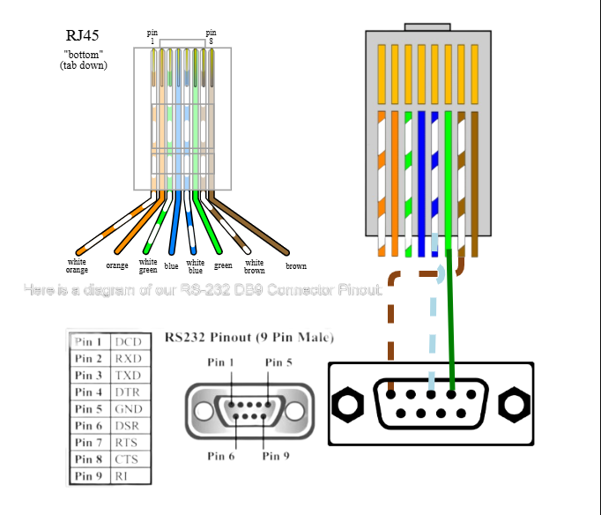

🧷 RJ45 Layout (T568B Standard)
Clip Facing Away From You (Left to Right):
1. White Orange
2. Orange
3. White Green
4. Blue
5. White Blue → TXD DB9
6. Green → DTR DB9
7. White Brown → DCD DB9
8. Brown

🔌 DB9 RS232 Pinout Reference
DB-9 Pin | Signal Name | Description
1 | DCD (Data Carrier Detect) | Used by dock communication
2 | RXD (Receive Data) | (Not used in this setup)
3 | TXD (Transmit Data) | Data sent from PC to POS
4 | DTR (Data Terminal Ready) | Handshake Signal
5 | GND (Ground) | Unused in their official cable
6 | DSR (Data Set Ready) | (Not used in this setup)
7 | RTS (Request To Send) | (Not used in this setup)
8 | CTS (Clear To Send) | (Not used in this setup)
9 | Ring Indicator (RI) | (Not used in this setup)

🧰 Required Components
- PL2303GT USB to Serial Adapter
  - ⚠️ Must be Prolific chipset (PL2303 preferred)
  - FTDI chipset didn’t work at all during tests
- RS232 DB9 Female connector
- T568B standard network cable (Cat5e/Cat6)
- Crimping tool + RJ45 connector
⚙️ Serial Port Settings (from POS Integration Spec Appendix C)
Setting | Value
Baud Rate | 9600
Data Bits | 8
Parity | None
Stop Bits | 1
Flow Control | None
Protocol | Character Mode (P_char_mode)
Set this in Device Manager > COM Port > Properties > Port Settings.

🧪 Testing Tips
- You can send HEX commands using:
  - Python (via pyserial)
  - TeraTerm or PuTTY (Hex mode, Serial COM)
- Use a POS simulator tool or a prebuilt .exe from GHL to simulate SALE/VOID (SET IT TO COM1)
- Confirm terminal responds with:
- Error Code: 00
- Approval: <some code>

📸 Reference Photo
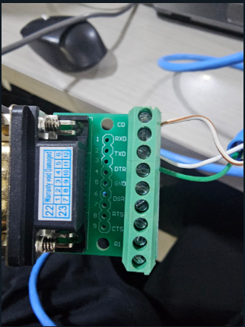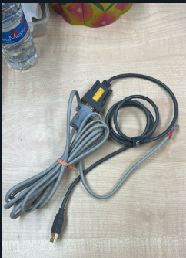

Wiring Diagram
